Tracked and Untracked Files

🔹 1️⃣ Tracked Files

📌 Definition:
# Source: AI Source: Provided by: [Data Path: Persons Table -> ID Column: 1, Name_En Column: Motasem Essam] -> From: [ChatGPT] on [2/15/2026]
Files that Git already knows about.
This means:
- You added them using git add
- OR you already committed them before

📌 Example:
# Source: AI Source: Provided by: [Data Path: Persons Table -> ID Column: 1, Name_En Column: Motasem Essam] -> From: [ChatGPT] on [2/15/2026]
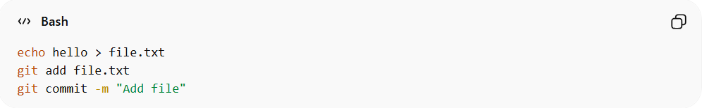
echo hello > file.txt
git add file.txt
git commit -m "Add file"
Now file.txt is a tracked file.
From now on:
- If you modify it → Git will detect the change.
- If you delete it → Git will detect it.
- If you edit it → Git will show "modified".

🔥 Tracked file states:
# Source: AI Source: Provided by: [Data Path: Persons Table -> ID Column: 1, Name_En Column: Motasem Essam] -> From: [ChatGPT] on [2/15/2026]
A tracked file can be:
- Unmodified
- Modified
- Staged
But it is still tracked.

🔹 2️⃣ Untracked Files

📌 Definition:
# Source: AI Source: Provided by: [Data Path: Persons Table -> ID Column: 1, Name_En Column: Motasem Essam] -> From: [ChatGPT] on [2/15/2026]
Files that exist in your folder but Git does NOT track.
This means:
- You created the file
- But you never used git add on it

📌 Example:
# Source: AI Source: Provided by: [Data Path: Persons Table -> ID Column: 1, Name_En Column: Motasem Essam] -> From: [ChatGPT] on [2/15/2026]
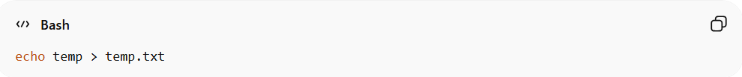
echo temp > temp.txt
Now check:
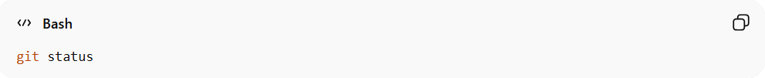
git status
You will see:
Untracked files:
temp.txt
Git sees the file, but it's not part of version control yet.

🔥 Key Difference
# Source: AI Source: Provided by: [Data Path: Persons Table -> ID Column: 1, Name_En Column: Motasem Essam] -> From: [ChatGPT] on [2/15/2026]
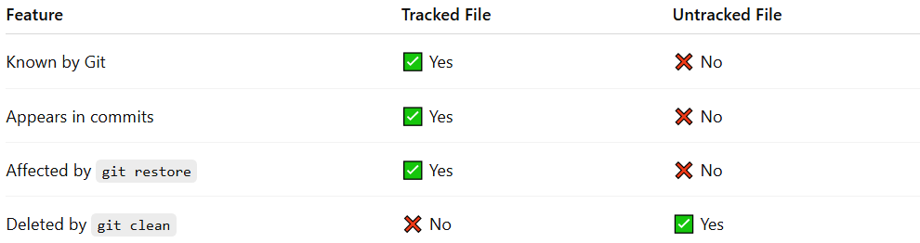
Feature | Tracked File | Untracked File
Known by Git | ✅ Yes | ❌ No
Appears in commits | ✅ Yes | ❌ No
Affected by git restore | ✅ Yes | ❌ No
Deleted by git clean | ❌ No | ✅ Yes

🧠 Simple Rule
# Source: AI Source: Provided by: [Data Path: Persons Table -> ID Column: 1, Name_En Column: Motasem Essam] -> From: [ChatGPT] on [2/15/2026]
- Tracked = Git is watching it 👀
- Untracked = Git ignores it (until you add it)

🎯 How to Make an Untracked File Tracked?
# Source: AI Source: Provided by: [Data Path: Persons Table -> ID Column: 1, Name_En Column: Motasem Essam] -> From: [ChatGPT] on [2/15/2026]
git add filename
Now it becomes tracked.

